Date: 18.07.2019
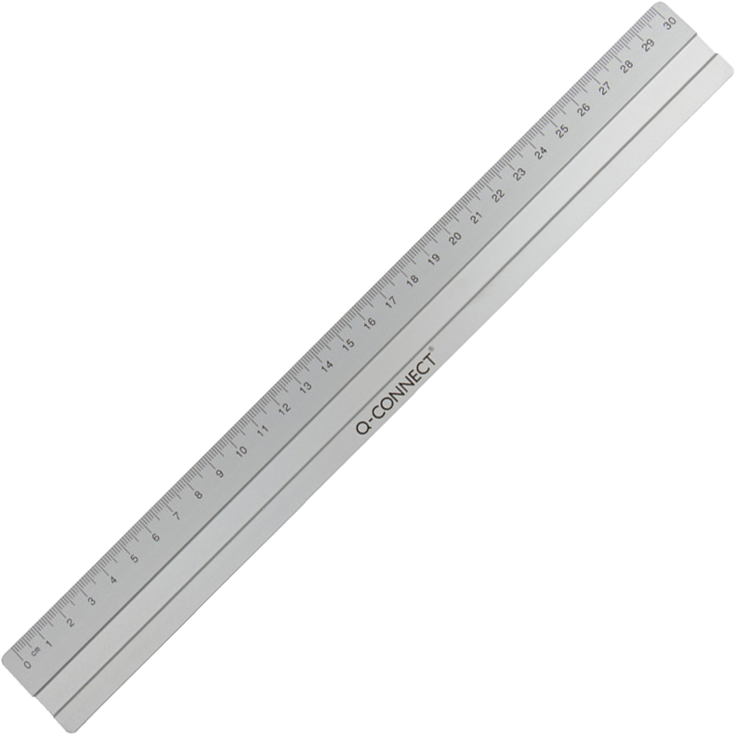
PRODUCT DATA SHEET
Item number:
KF03678 / E-10291 IA
Brand Name:
Q-Connect Aluminium Ruler
Description:
Aluminium Rulers, anti slip rubber, metric scale 30cm

PRODUCT INFORMATION
Colour: | Blade material:
silver | Aluminium
Full length: | Handle material:
31 cm | -
Shape of tip: | Product Weight
- | 0,028 kg
Product Origin | Customs tariff number:
China | 90178010

LOGISTIC INFORMATION
Single packaging | Single Weight | Single Measures | Unit
Blister | 0,029 kg | 35,8 x 4,7 x 0,5 cm | 1
Inner packaging | Inner Weight | Inner Measures | Units by box
Carton box | 0,30 kg | 32,6 x 4,6 x 5 cm | 10
Master packaging | Master Weight | Master Measures | Units by box
Carton box | 4,9 kg | 33,5 x 20 x 21 cm | 160
EAN Single: | 5705831036789
EAN Inner: | 5706002036782
EAN Master: | 5706003036781

MARKETING TEXT
Q-CONNECT Aluminium ruler with anti-slip rubber and indelible cm and inch scale. 30cm/12”

