Date: 18.07.2019
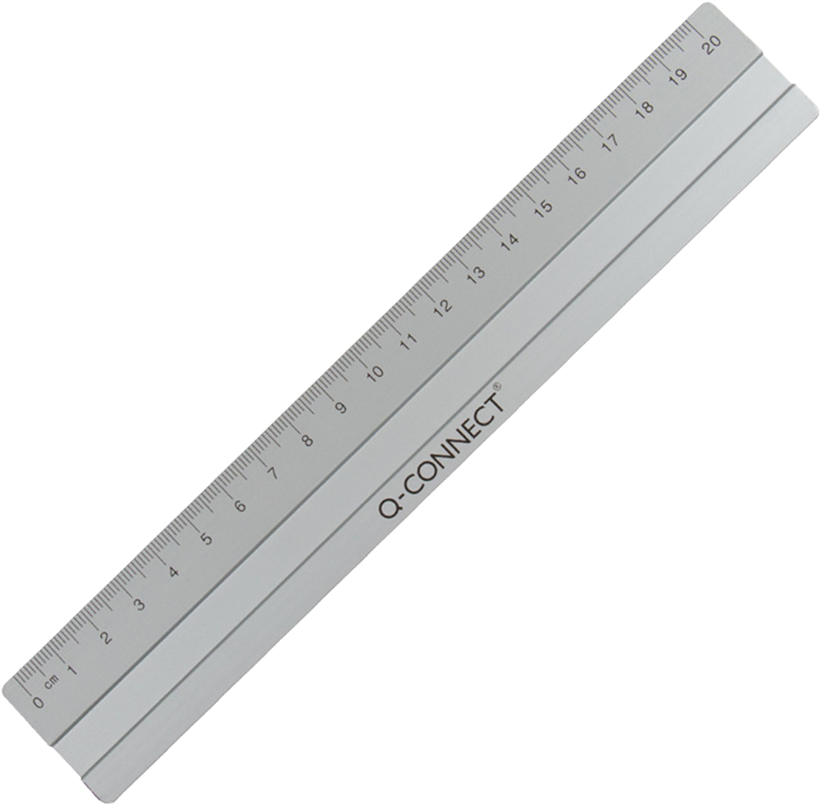
PRODUCT DATA SHEET
Item number:
KF03677 / E-10290 IA
Brand Name:
Q-Connect Aluminium Ruler
Description:
Aluminium Rulers, anti slip rubber, metric scale 20cm

PRODUCT INFORMATION
Colour: | Blade material:
silver | Aluminium
Full length: | Handle material:
21 cm | -
Shape of tip: | Product Weight
- | 0,016 kg
Product Origin | Customs tariff number:
China | 90178010

LOGISTIC INFORMATION
Single packaging | Single Weight | Single Measures | Unit
Blister | 0,017 kg | 26 x 4,5 x 0,5 cm | 1
Inner packaging | Inner Weight | Inner Measures | Units by box
Carton box | 0,20 kg | 22,6 x 4,1 x 4,9 cm | 10
Master packaging | Master Weight | Master Measures | Units by box
Carton box | 3,8 kg | 29,5 x 24,3x16,5cm | 180
EAN Single: | 5705831036772
EAN Inner: | 5706002036775
EAN Master: | 5706003036774

MARKETING TEXT
Q-CONNECT Aluminium ruler with anti-slip rubber and indelible cm and inch scale. 20cm/8”

